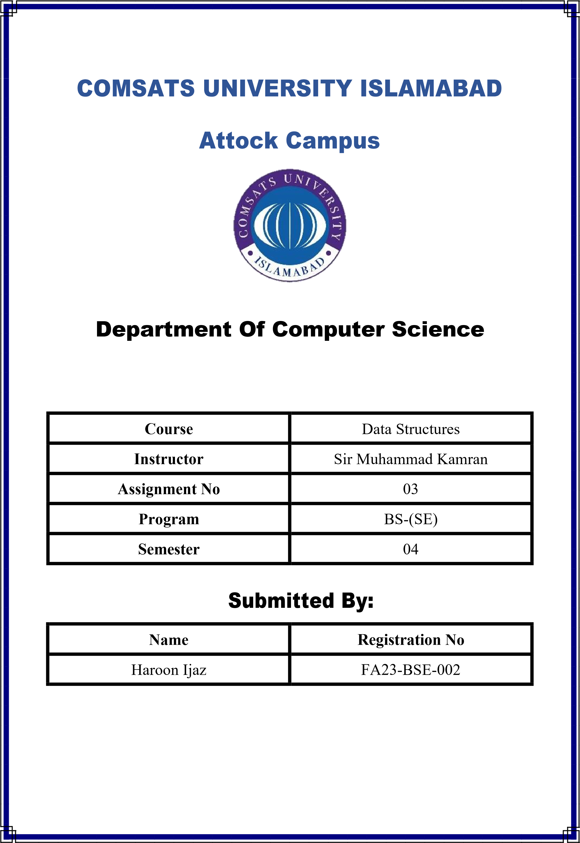

**Min-Heap Implementation**

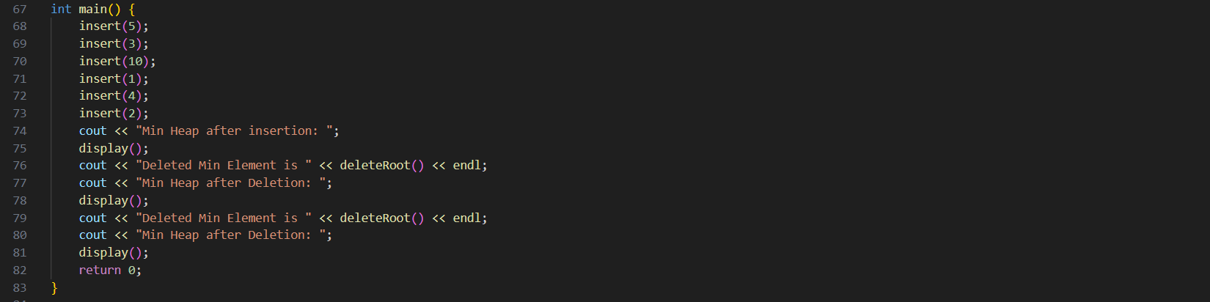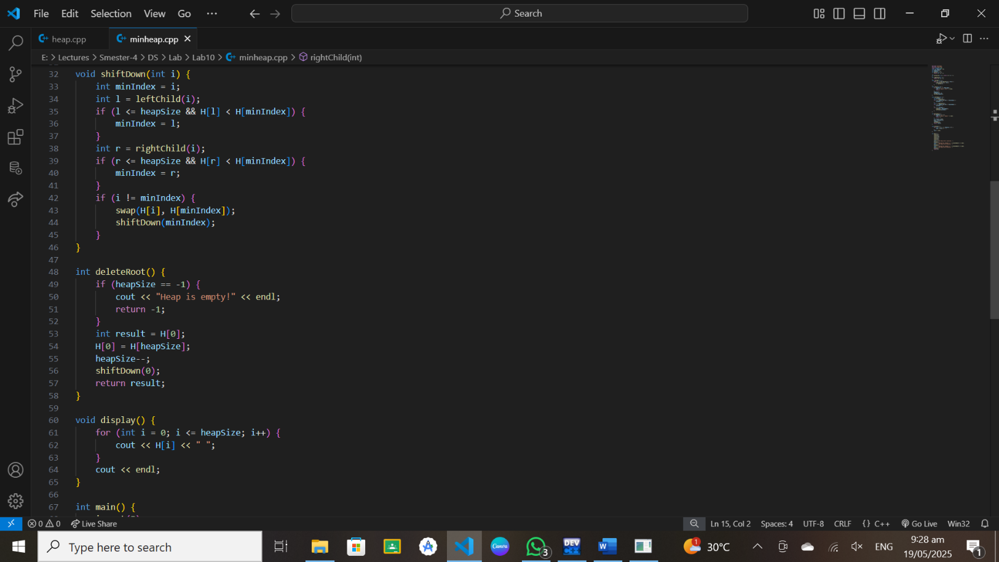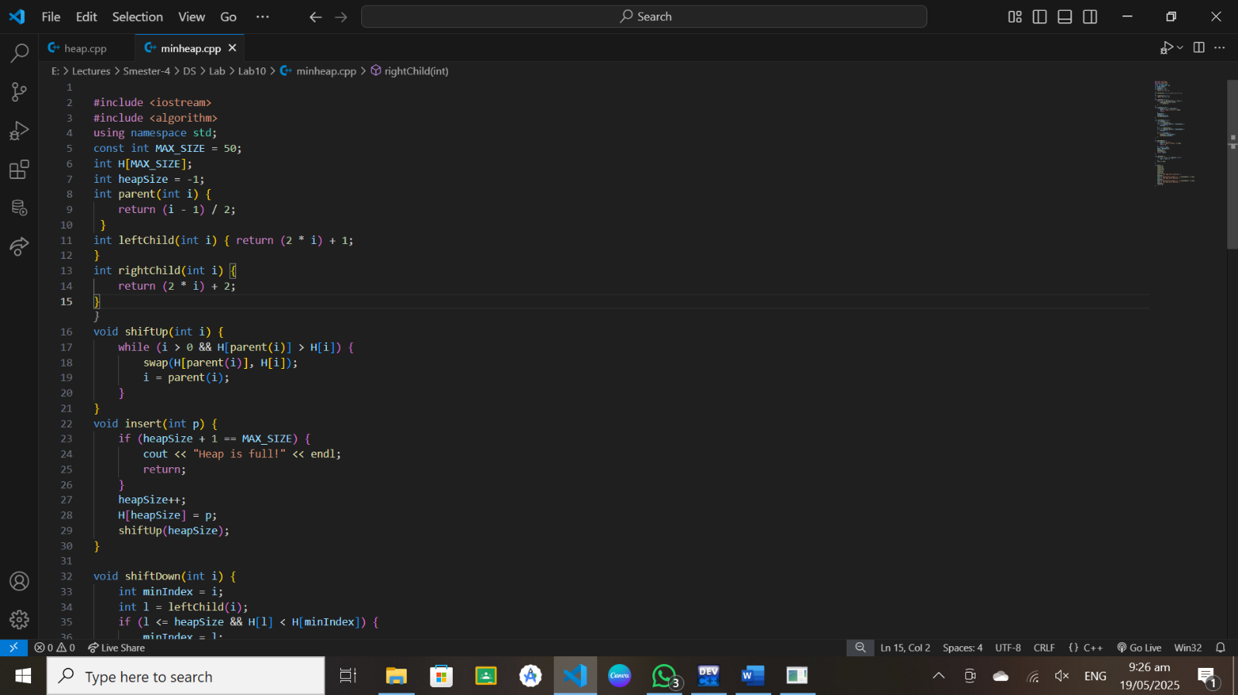**Code:**

**Output:**